DATE:21.08.2025

EXPERIMENT – 13 Create a Virtual Machine with 1 CPU, 2GB RAM and 15GB storage disk using a Type 2 Virtualization Software using Vmware workstation.

Aim:

To create and configure a Virtual Machine with 1 CPU, 2 GB RAM, and 15 GB storage using a Type-2 Virtualization Software (VMware Workstation).

Procedure

1. Install and launch VMware Workstation on the host operating system.
2. Click File → New Virtual Machine (Ctrl+N).
3. In the wizard:
   * Select Typical (recommended) and click Next.
   * Choose Installer disc image (ISO) or Install later.
4. Assign a name to the VM and choose the storage location.
5. Set the Virtual Disk Size to 15 GB and select *Store virtual disk as a single file*.
6. Click on Customize Hardware:
   * Set Processors: 1 CPU.
   * Set Memory (RAM): 2048 MB (2 GB).
   * Verify Hard Disk: 15 GB.
   * Attach the OS ISO to the CD/DVD drive if installing an operating system.
7. Click Finish to create the Virtual Machine.
8. Power on the VM to start the OS installation.
9. Verify the configured resources (CPU, RAM, Disk) from the VM settings.

Output:

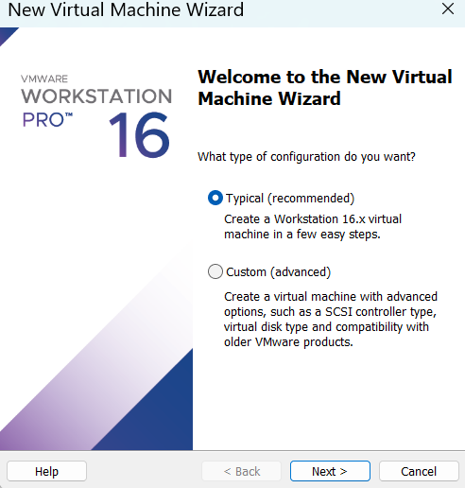

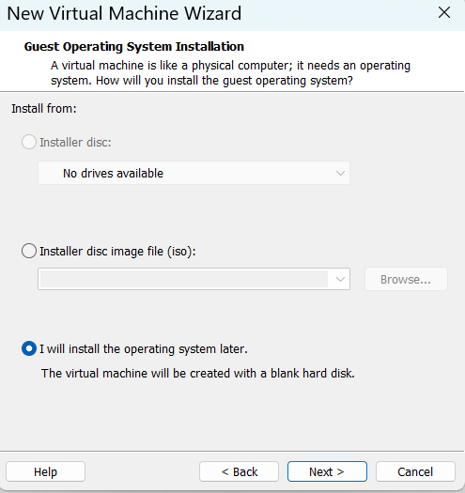

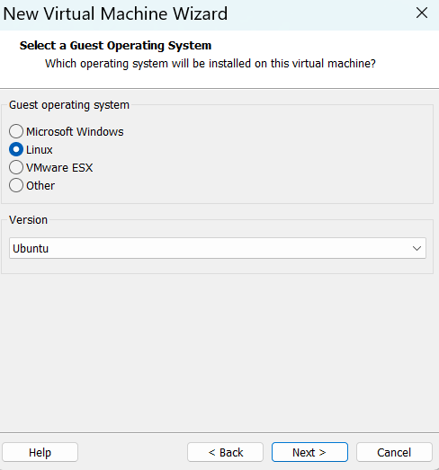

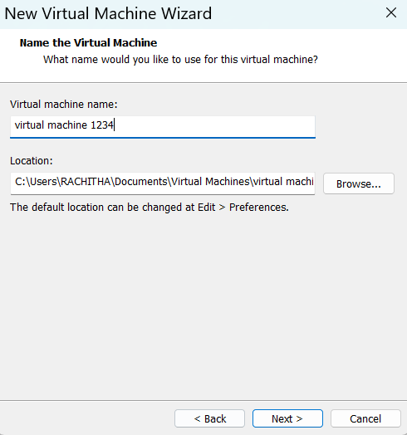

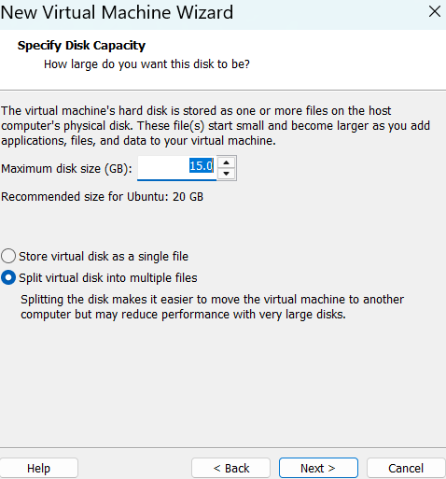

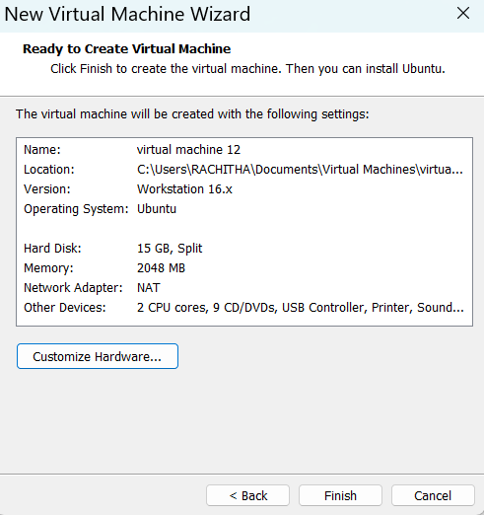

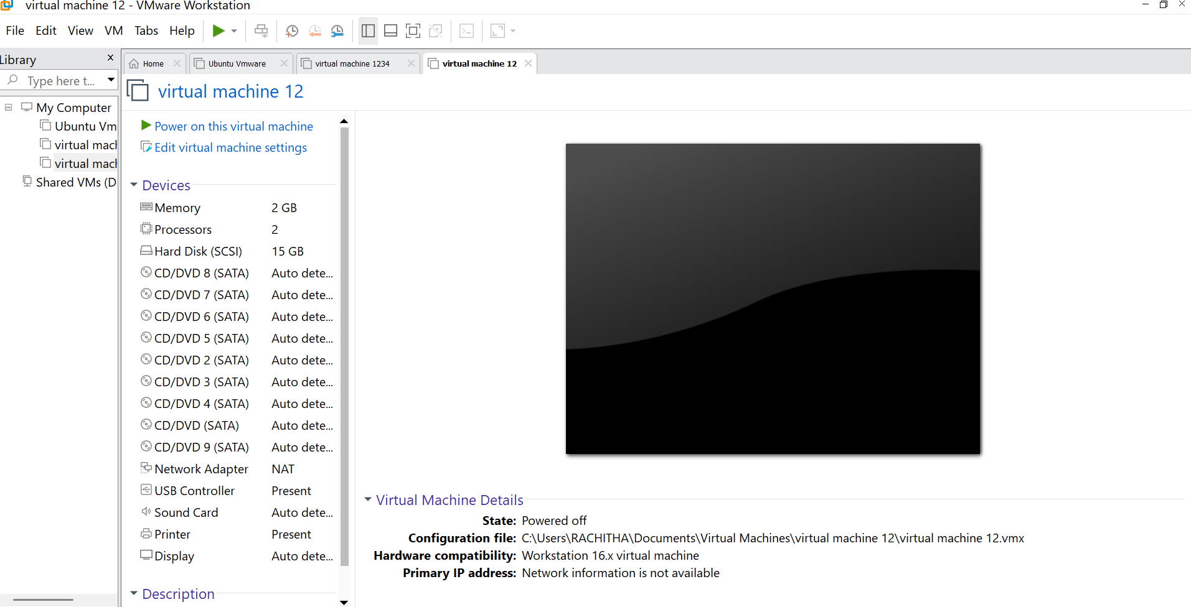

Result:

A Virtual Machine with 1 CPU, 2 GB RAM, and 15 GB storage was successfully created using VMware Workstation (Type-2 Hypervisor). The VM is ready for operating system installation and execution.